ICGEC 2016 Keynote Speaker
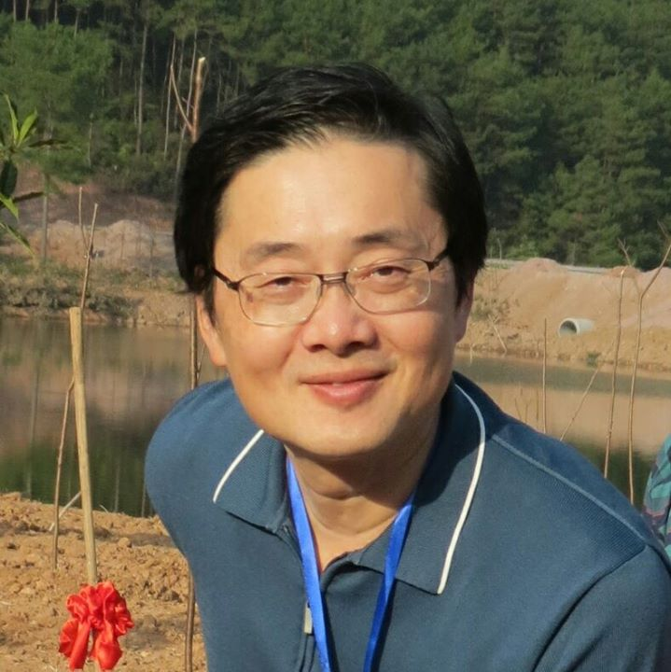

Prof. Han-Chieh Chao

President
National Dong Hwa University, Taiwan

Affiliation
- Department of Electrical Engineering, National Dong Hwa University, Halien, Taiwan
- Department of Computer Science and Information Engineering and the Department of Electronic Engineering, National Ilan University, I-Lan, Taiwan

Keynote title: IoT and Big Data Applications

Abstract
Since technologies regarding Internet of Things (IoT) and cloud computing have been rapidly developed, big data analytics and applications grow incrementally. IoT technology is widely used in environmental management, industrial monitoring, smart cities, health care and other applications, thus it brings a vastly numerous amount of data. However, the generated data without analysis is incomprehensible to human being. Therefore, big data analytics is vital to IoT applications and further brings various high value added big data applications. First of all, this keynote speech addresses the current status about IoT and big data. Then, the six As and Cs of IoT and the four Vs of big data are introduced respectively. Moreover, some applications of IoT and big data are given in this keynote speech. Finally, a proposed framework for big data from cloud-IoT IMS is also given.

Speaker bio

Dr. Han-Chieh Chao is a joint appointed Chair Professor of the Department of Computer Science & Information Engineering, Electronic Engineering of National Ilan University, I-Lan, Taiwan (NIU) and Fujian University of Technology. He is serving as the President since 2016 for NDHU as well. He was the Director of the Computer Center for Ministry of Education Taiwan from September 2008 to July 2010. His research interests include High Speed Networks, Wireless Networks, IPv6 based Networks, Digital Creative Arts, e-Government and Digital Divide. He received his MS and Ph.D. degrees in Electrical Engineering from Purdue University in 1989 and 1993 respectively. He has authored or co-authored 4 books and has published about 400 refereed professional research papers. He has completed more than 150 MSEE thesis students and 5 PhD students. Dr. Chao has been invited frequently to give talks at national and international conferences and research organizations. Dr. Chao is the Editor-in-Chief for IET Networks, Journal of Internet Technology. He is the founding Edtor-in-Chief for International Journal of Internet Protocol Technology, and International Journal of Ad Hoc and Ubiquitous Computing. He is also the associate editor for IEEE Network Magazine and IEEE Wireless Communications Magazine. Dr. Chao has served as the guest editors for Mobile Networking and Applications (ACM MONET), IEEE JSAC, IEEE Communications Magazine, IEEE Systems Journal, Computer Communications, IEE Proceedings Communications, the Computer Journal, Telecommunication Systems, Wireless Personal Communications, and Wireless Communications & Mobile Computing. Dr. Chao is an IEEE senior member and a Fellow of IET (IEE).

