A Brief Introduction to Fuzzy Systems

Chin-Shiuh Shieh (謝欽旭)
csshieh@nkust.edu.tw

Department of Electronic Engineering
National Kaohsiung University of Applied Sciences

2015-05-26

Fuzzy Systems

- Fuzzy systems, pioneered by Zadeh[1965], try to cope with the inexact nature of real world and to model the mental activity of human beings.

- Conventional control theory demands exact models to have things under control. However, exact models could be unavailable or infeasible in ill-structured problems, such as bicycle riding, task demanding skilled expertise.

- Crisp value vs. fuzzy value
- Temperature T=25℃, T=50℃ are crisp.
- Temperature is MILD, temperature is HIGH are fuzzy.

- Membership functions define fuzzy values (fuzzy sets)
- For T=40℃, the temperature is somewhat LOW (with a degree of 0.8), somewhat MILD (with a degree of 0.2), but not HIGH.
MILD
HIGH
LOW
50℃
100℃
0℃
1

- Crisp rule vs. fuzzy rule
- If D=0.75 m and V=0.25 m/s, then F=-0.3 N
- If Distance=FAR and Velocity=LOW, then Force=NEGATIVE.

A Sample Fuzzy Controller – Target Tracer

- One-Dimensional Target Tracer

- Input variables:
Tracer
Target
Distance = Target’s Position – Tracer’s Position (m)
Velocity: Tracer’s Velocity (m/s)
- Output variable:
Force: Tracer’s Driving Force (N)
- Objective:
Driving the Tracer to trace the Target
- Defining Fuzzy Sets

- Distance
PO: Positive, ZE: Zero, NE: Negative
- Velocity
PO: Positive, ZE: Zero, NE: Negative
- Force
PO: Positive, ZE: Zero, NE: Negative
ZE
PO
NE
-1m
-1m/s
-1N
0m
0m/s
0N
1m
1m/s
1N

- Coding Fuzzy Rules

If Distance is PO and Velocity is PO then Force is set to ZE. (1)
If Distance is PO and Velocity is ZE then Force is set to PO. (2)
If Distance is PO and Velocity is NE then Force is set to PO. (3)
If Distance is ZE and Velocity is PO then Force is set to NE. (4)
If Distance is ZE and Velocity is ZE then Force is set to ZE. (5)
If Distance is ZE and Velocity is NE then Force is set to PO. (6)
If Distance is NE and Velocity is PO then Force is set to NE. (7)
If Distance is NE and Velocity is ZE then Force is set to NE. (8)
If Distance is NE and Velocity is NE then Force is set to ZE. (9)

- Control Table

Force |  | Velocity
 |  | PO | ZE | NE
Distance | PO | ZE | PO | PO
Distance | ZE | NE | ZE | PO
Distance | NE | NE | NE | ZE

- Fuzzy Reasoning

- Fuzzification by matching crisp input with fuzzy sets.

- Fuzzy inference by multiplying match scores for each antecedents.

- Defuzzification by taking centroid of weighted consequents.

- Ex. Distance=0.25, Velocity=0.75 ➔ Force=-0.4271845
Rule (1)
Rule (2)
Rule (4)
Rule (5)
Rule (3)
Match score
=0.25*0.75
Match score
=0.25*0.25
Match score
=0.75*0.75
Match score
=0.75*0.25
Match score
=0.25*0.0

- Experiment Result:
http://bit.kuas.edu.tw/~csshieh/research/program/fuzzy.zip
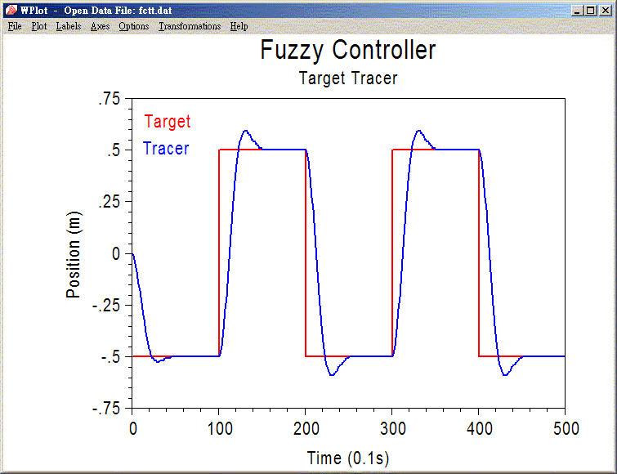

Important Characteristics

- Rule-based: Benefit of symbolic system was preserved by coding expertise into fuzzy rules described by linguistic variables.

- Robust: The representation scheme and inference process of fuzzy systems are inherently immune to environmental noise, change in system parameters, and damage of rule base.

- Easy-prototyping: Workable prototype can be easily constructed, and then tuned according to actual operation data.

- Highly representative: The fuzzy rules are perceivable to human being. This characteristic is crucial if a fuzzy system can learn new rules or adapt old rules by itself.

- Both symbolic and numerical: Rules are stored symbolically and inferred numerically making fuzzy systems able to response to wide range of input by only a few rules.

Related Issues

- Membership Function: triangle, Gaussian, …

- Inference Scheme: multiplying, taking maximal, …

- Defuzzification: centroid, weighted crisp consequents, …

Research Topics

- Application to ill-structured problems where exact models are unavailable, infeasible, or subject to change.

- Universal function approximater.

- Automatic development of fuzzy sets and rules, instead of hand-coding and fine-tuning by human experts.

- Establishment of theoretical foundation.

Personal Experience

- Automatic Development of Fuzzy Rules
Tuning of membership functions based on approximation error using gradient-descent method and heuristic re-initialization.
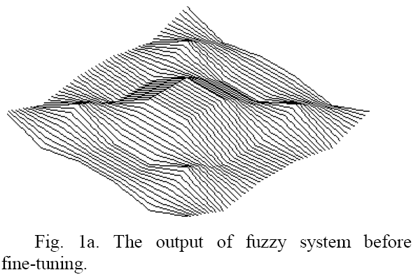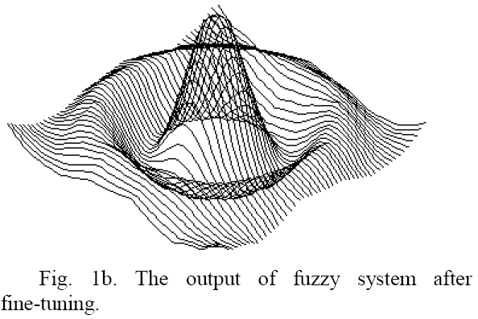
- Credit Assignment of Fuzzy Rules
Assign credit to individual rules according to their on-line performance in terms of scalar payoff.

[0] if dv = LEFTUPPER then force = DOWN
[1] if dv = LEFTUPPER then force = ZERO
[2] if dv = LEFTUPPER then force = UP
[3] if dv = AROUND then force = DOWN
[4] if dv = AROUND then force = ZERO
[5] if dv = AROUND then force = UP
[6] if dv = RIGHTLOWER then force = DOWN
[7] if dv = RIGHTLOWER then force = ZERO
[8] if dv = RIGHTLOWER then force = UP
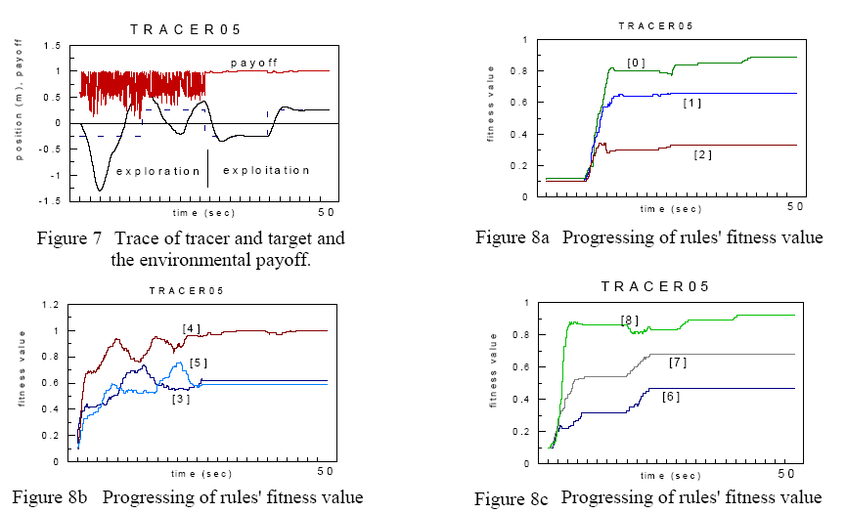

Reference
- 中國生產力中心技術引進服務組 ( 編譯), FUZZY理論與應用實務, 全華, 台北, 1992.
- Klir, G. J., St.Clair, U., and Yuan, B., Fuzzy Set Theory – Foundations and Applications, Prentice Hall, 1997.
- Zadeh, L. A., "Fuzzy Sets," Information and Control, vol. 8, 338-353, 1965.
- Shieh, C.-S., Chu, S.-C., and Liao, B.-Y., “Fuzzy function approximation by gradient-descent fine-tuning and informed re-initialization,” in Proceedings of the Fourth International Conference on Electronic Measurement and Instruments (ICEMI'99), pp. 997-1003, Harbin, China, 1999.
- Shieh, C.-S. and Wang, S.-D., “Automatic development of fuzzy rule bases by gradient-descent fine-tuning and heuristic re-initialization,” in Proceedings of the 1997 Fifth National Conference on Fuzzy Theory and Applications (Fuzzy’97), pp. 519-524, 1997.

